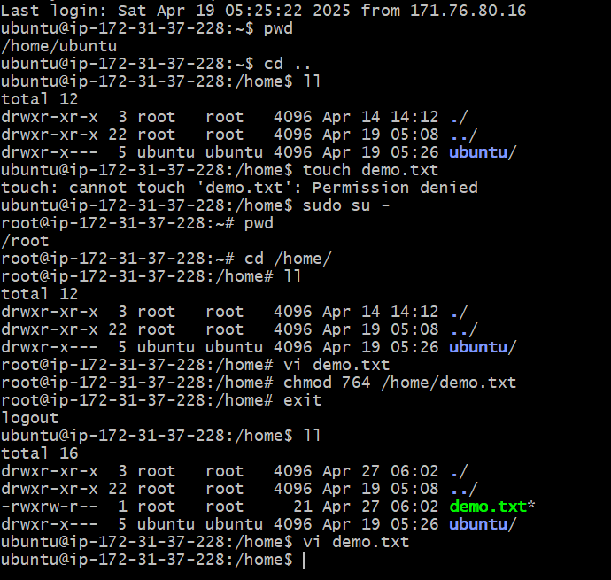

Was not able to create Demo.txt as ubuntu user doesn’t have write access in /home

======================================================================

ubuntu@ip-172-31-37-228:/home$ touch demo.txt

touch: cannot touch 'demo.txt': Permission denied

Logged in as root user and created Demo.txt under /home

===================================================

ubuntu@ip-172-31-37-228:/home$ sudo su -

root@ip-172-31-37-228:~# pwd

/root

root@ip-172-31-37-228:~# cd /home/

root@ip-172-31-37-228:/home# vi demo.txt

Changing the permission for Demo.txt such that root(owner) has read/write/execute access

group can read/write

Other user like ubuntu has only read access

===================================================

root@ip-172-31-37-228:/home# chmod 764 /home/demo.txt

root@ip-172-31-37-228:/home# exit

logout

ubuntu@ip-172-31-37-228:/home$ ll

total 16

drwxr-xr-x 3 root root 4096 Apr 27 06:02 **.**/

drwxr-xr-x 22 root root 4096 Apr 19 05:08 **..**/

-rwxrw-r-- 1 root root 21 Apr 27 06:02 **demo.txt**\*

drwxr-x--- 5 ubuntu ubuntu 4096 Apr 19 05:26 **ubuntu**/

ubuntu@ip-172-31-37-228:/home$ vi demo.txt

